**Comprehensive database schema design**

Below is the final, comprehensive database schema for your Hotel Room Reservation and Management System, including:

1. Purpose of Each Table
2. Table Columns (Name, Data Type, Description)
3. Relationships
4. Database Schema vs. System Requirements Review

**★ Users Table**

**Purpose:** Stores information about all system users (administrators, front desk staff, housekeeping staff, and guests). Manages roles and authentication details.

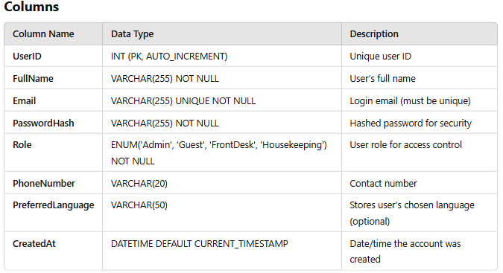

**Relationships**

* **One-to-Many** with **Bookings**: A user (guest) can have multiple bookings.
* **One-to-Many** with **Payments**: A user can make multiple payments.
* **One-to-Many** with **Housekeeping** (if the user is housekeeping staff).
* **One-to-Many** with **Reviews**: A user can leave multiple reviews.
* **One-to-Many** with **Notifications**: A user can receive multiple notifications.

**★ Rooms Table**

**Purpose:** Manages hotel rooms, their types, statuses, and pricing.

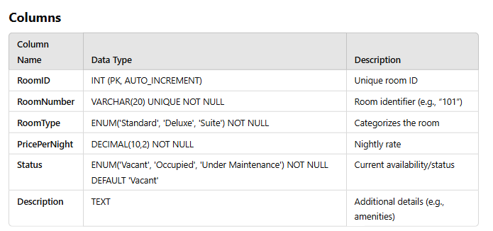

**Relationships**

* **One-to-Many with Bookings**: A room can be booked many times (different dates).
* **One-to-Many with Housekeeping:** A room can have multiple housekeeping tasks over time.

★ **Bookings Table**

**Purpose:** Handles all reservation details, linking guests to specific rooms for a date range. Also tracks check-in/check-out status.

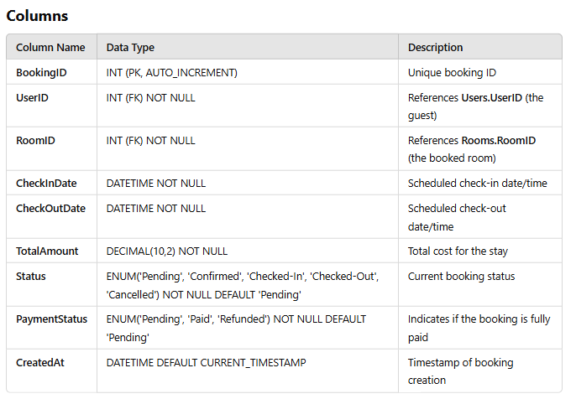

**Relationships**

* **Many-to-One** with **Users** (a guest can have multiple bookings).
* **Many-to-One** with **Rooms** (a room can have multiple bookings over time).
* **One-to-One** or **One-to-Many** with **Payments** (one booking can have multiple partial payments or a single payment record).
* **One-to-Many** with **Services** (one booking can include multiple special services).

**★ Payments Table**

**Purpose:** Tracks all payment transactions, including method, amount, and date. Links to bookings and users for billing and invoice management.

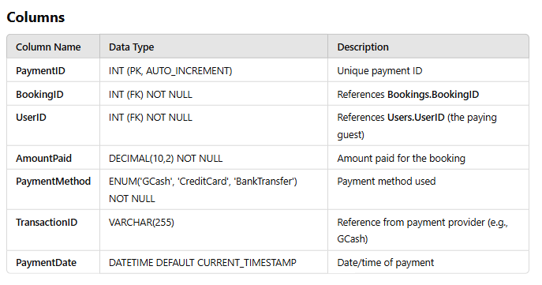

**Relationships**

* **Many-to-One with Bookings (a booking can have multiple payments or just one).**
* **Many-to-One with Users (a user can make multiple payments).**

★ **Housekeeping Table**

**Purpose:** Organizes housekeeping and maintenance tasks, assigning them to staff and tracking statuses

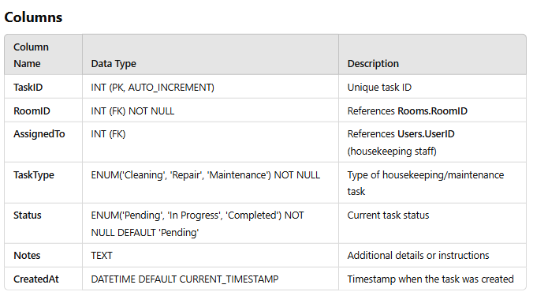

**Relationships**

* **Many-to-One with Rooms (a room can have multiple housekeeping tasks).**
* **Many-to-One with Users (if assigned to a specific housekeeping staff member).**

**★ Reviews Table**

**Purpose:** Collects feedback and ratings from guests, helping improve service quality.

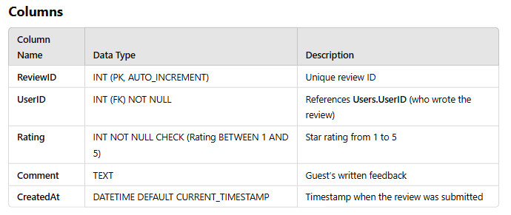

**Relationships**

* **Many-to-One with Users (a user can leave multiple reviews).**

**★ Notifications Table**

**Purpose:** Manages automated or manual notifications (booking confirmations, reminders, promotional messages).

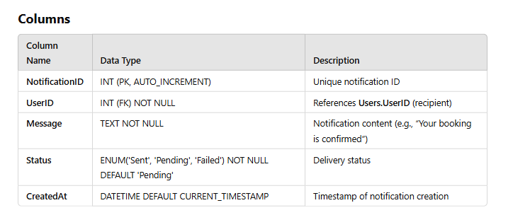

**Relationships**

* **Many-to-One with Users (a user can have multiple notifications).**

**★ Promotions Table**

**Purpose:** Stores discount codes, loyalty offers, and promotional packages.

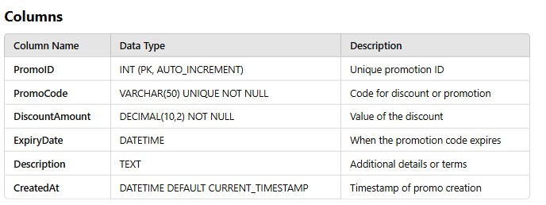

**Relationships**

* Currently standalone; you can apply these promotions in Bookings or Payments logic at the application layer.

**★ Services Table**

**Purpose:** Facilitates additional services (spa bookings, airport transfers, room service) linked to a booking.

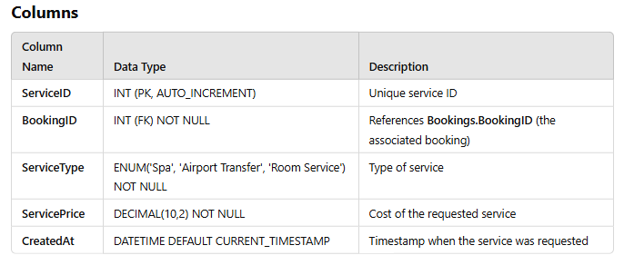

**Relationships**

* **Many-to-One** with **Bookings** (a booking can have multiple additional services).

**Relationships Overview (ERD Summary)**

* **Users (1) --- (∞) Bookings**
* **Rooms (1) --- (∞) Bookings**
* **Bookings (1) --- (∞) Payments**
* **Users (1) --- (∞) Payments**
* **Rooms (1) --- (∞) Housekeeping**
* **Users (1) --- (∞) Housekeeping (for assigned staff)**
* **Users (1) --- (∞) Reviews**
* **Users (1) --- (∞) Notifications**
* **Bookings (1) --- (∞) Services**

***(“1” stands for “one”, “∞” stands for “many”)***

**Database Schema vs. System Requirements Review**

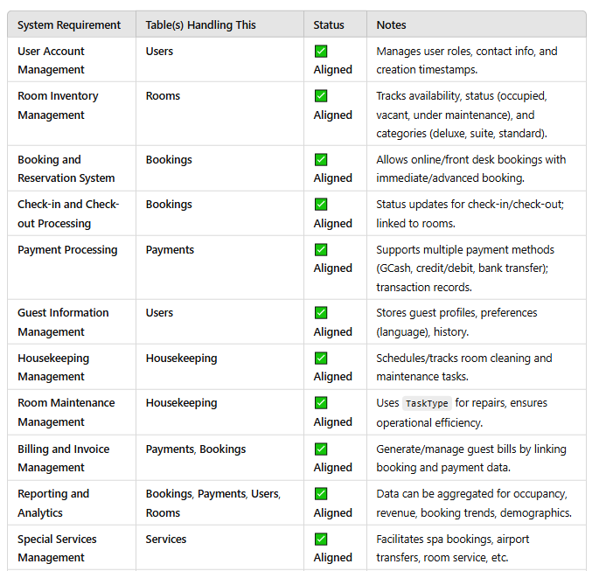

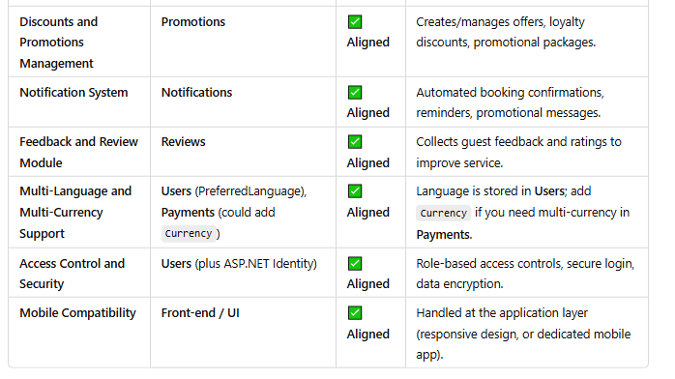

**Conclusion**

* **All tables** and **columns** are present to satisfy the **Hotel Room Reservation and Management System** requirements.
* **Relationships** ensure data integrity and proper linkage between entities (Users, Rooms, Bookings, etc.).
* Optional **multi-currency** can be easily integrated by adding a Currency column in **Payments**.

You now have a **clear, text-based reference** for each table’s **purpose, columns, and relationships**, plus a **requirements checklist** to confirm full coverage.